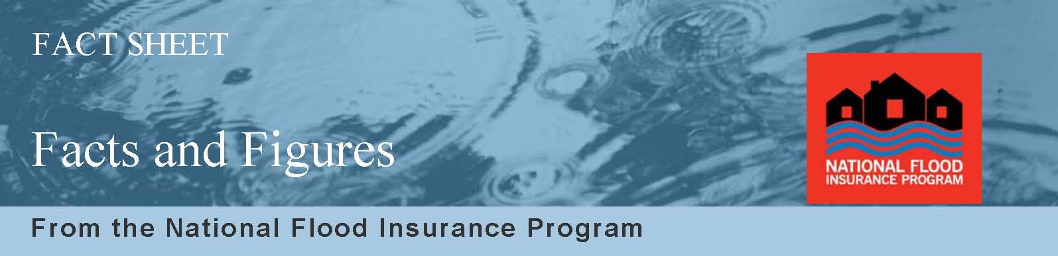

Many people do not know the basics about flooding or flood insurance. To make informed decisions, consumers need a solid understanding of their flood risk and flood insurance. The following are important facts and figures that provide a good picture of the risk of flooding, its impact and options for protection.
RISK
- Floods are the number one natural disaster in the United States.
- Everyone is at risk —even those not near flooding sources like rivers and lakes. Floods happen as a result of heavy rains, snow melt, overloaded drainage systems, land development runoff, and for many more reasons. Just an inch of water can cause tens of thousands of dollars in damage to property, including your personal contents.
- Most homeowners insurance doesn’t cover flood damage.
- In a high-risk area, your home is more than twice as likely to be damaged by flood than by fire.
- More than 5 million Americans are protected with flood insurance, but millions more are unaware of their personal risk for property damage — or options for protection.
- In the South and West, approximately 24 percent of homeowners in high-risk areas, or Special Flood Hazard Areas (SFHAs), are covered by flood insurance. However, outside of the high-risk areas, three percent of homeowners in non-SFHAs have purchased flood insurance (Source: RAND Corporation).
IMPACT
- Flood losses in the United States averaged $2.4 billion per year for the last decade.
- The National Flood Insurance Program (NFIP) paid more than $4 billion in flood insurance claims to policyholders in the past two years (as of May 2010).
- Federal disaster assistance is usually a loan that must be paid back with interest — and is only available when a disaster has been federally declared.
- In the last 50 years, nearly 1,000 flood events have been designated as federally declared disasters.
- Nearly 75 percent of all federally declared disasters over the past five years involved flooding.
- In Northeast and Midwest SFHAs, the flood insurance coverage is significantly lower than in other areas of the United States. Nearly 87 percent of Northeast residents and nearly 93 percent of Midwesterners lack financial protection in case of a flood (Source: RAND Corporation).

- Property owners, renters and business owners can purchase flood insurance on their building and contents if their community is among the nearly 21,000 communities that participate in the NFIP.
- It typically takes 30 days after the purchase of flood insurance for the policy to take effect.
- The average flood insurance policy cost less than $570 per year.
- People in moderate-to-low risk areas may be eligible for the Preferred Risk Policy with flood insurance premiums starting as low as $129 a year.
- Consumers can visit FloodSmart.gov or call 1-800427-2419 to learn how to prepare for floods, how to purchase a flood insurance policy and what the benefits are of protecting their homes and contents against flooding.

